HANDS-ON 5

Objectives

Explain how to clean up and push back to remote Git
How to clean up and push back to remote Git
- Check the status to see if there are any changes that need to be committed:
git status
- Stage your changes (add files you want to commit):
git add .
- Commit your changes with a meaningful message:
git commit -m "Your commit message"
- Pull the latest changes from the remote branch to avoid conflicts:
git pull origin main
(Replace main with your branch name)
- Push your committed changes back to the remote repository:
git push origin your-branch-name
1. Verify if main branch is in a clean state
Command:
git status
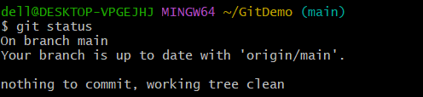

2. Create a test file with some content
Command:
echo "This is a test change" > testfile.txt
3. Add the new file to staging
Command:
git add testfile.txt
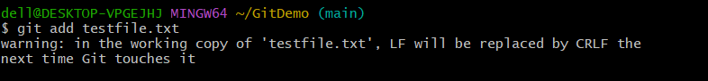
4. Commit the changes
Command:
git commit -m "Added testfile.txt to verify push functionality"
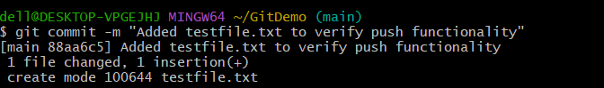
5. Push the changes to remote
Command:
git push origin Git-T03-HOL_002
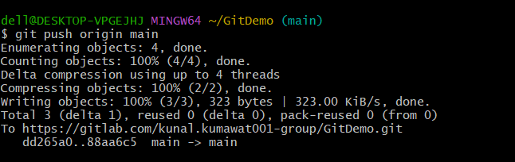

6. Verify the latest commit pushed
Command:
git log -1
